GenAI and Prompt Engineering Workshop

The Department of Information and Technology recently hosted an engaging workshop in collaboration with the **IEEE Information Theory Society student chapter (SBC64622D)** from July 25th to July 27tth, 2024. The event, conducted both offline and through webinars, featured Mr.Manoj as the keynote speaker. Mr.Manoj captivated the audience with his expertise, delving into the intricacies of "GenAI: Two-Day Workshop Deep Dive into ML, Python,Prompt Engineering, and Generative AI." With a blend of theoretical insights and practical applications, the workshop provided participants with a comprehensive understanding of cutting-edge technologies in the field of artificial intelligence.

The workshop not only offered theoretical knowledge but also provided hands-on sessions, allowing students to apply concepts learned directly to real-world scenarios. The attendees, predominantly 3rd-year students from the IT department, actively engaged in interactive sessions, gaining practical experience in machine learning, Python and prompt engineering. Mr.Manoj expertise and the collaborative efforts of the organizers ensured a fruitful learning experience, empowering participants with the skills and knowledge essential for navigating the evolving landscape of AI technologies. The workshop served as a platform for fostering innovation and collaboration, paving the way for the next generation of AI enthusiasts to make significant strides in the field.

Mr.Vamsi Krishna Sudapalli, Flipkart Project Manager, Centre Head Bangalore, addressed the hands on workshop and delivered lot of points on project coordination and retaining jobs at IT industry.

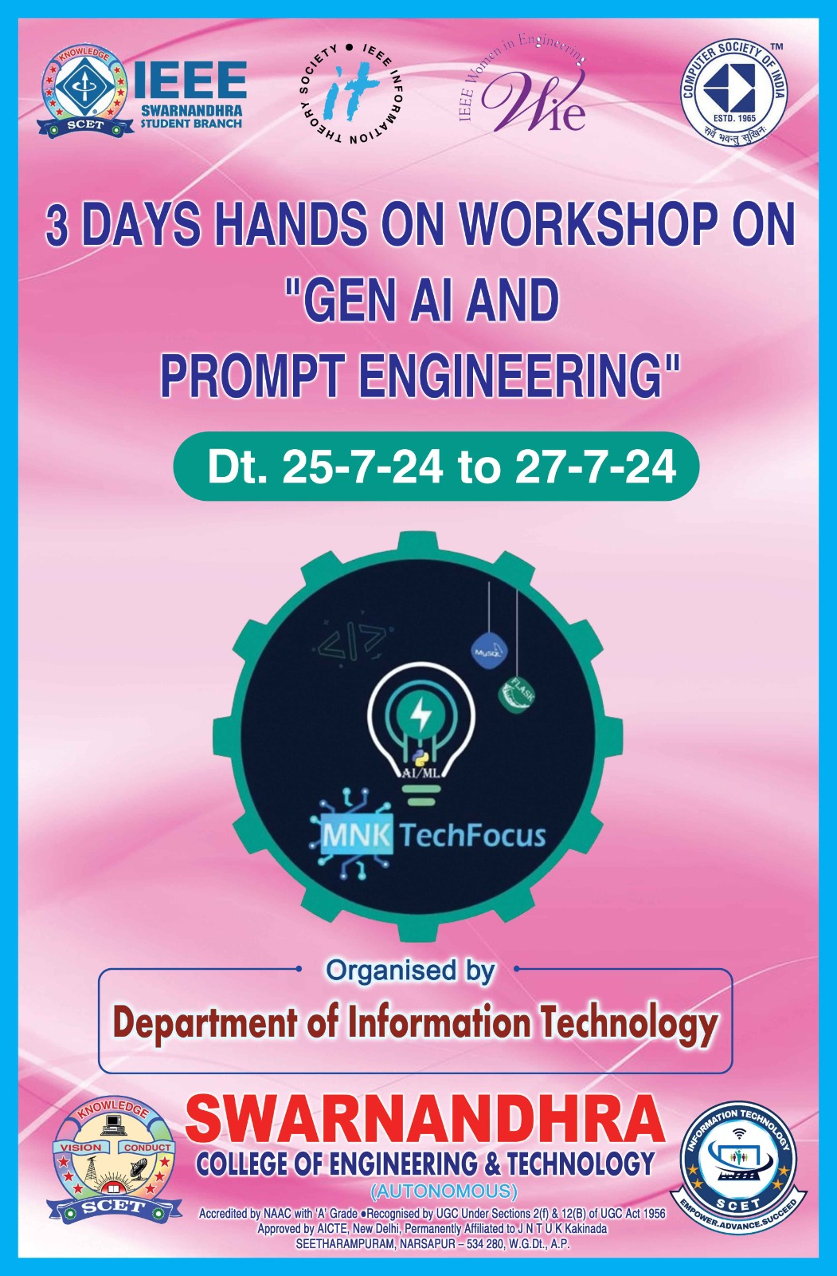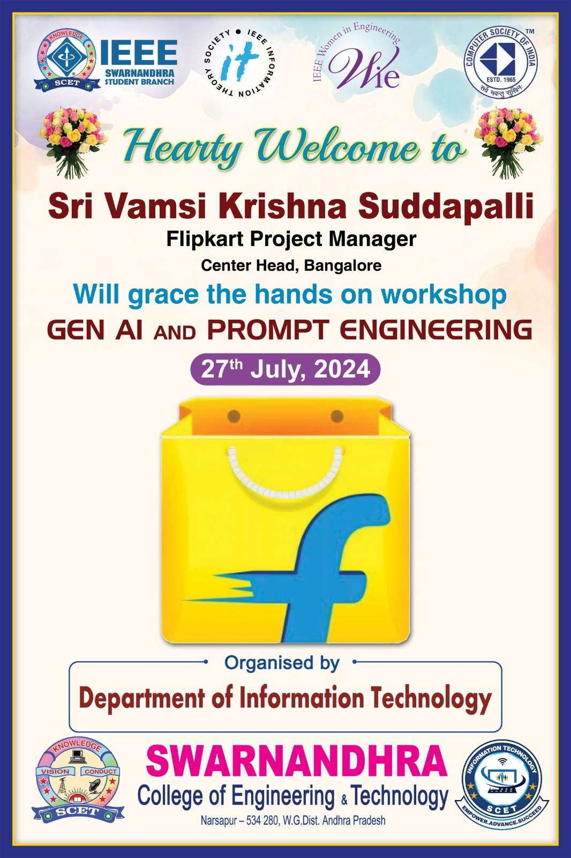

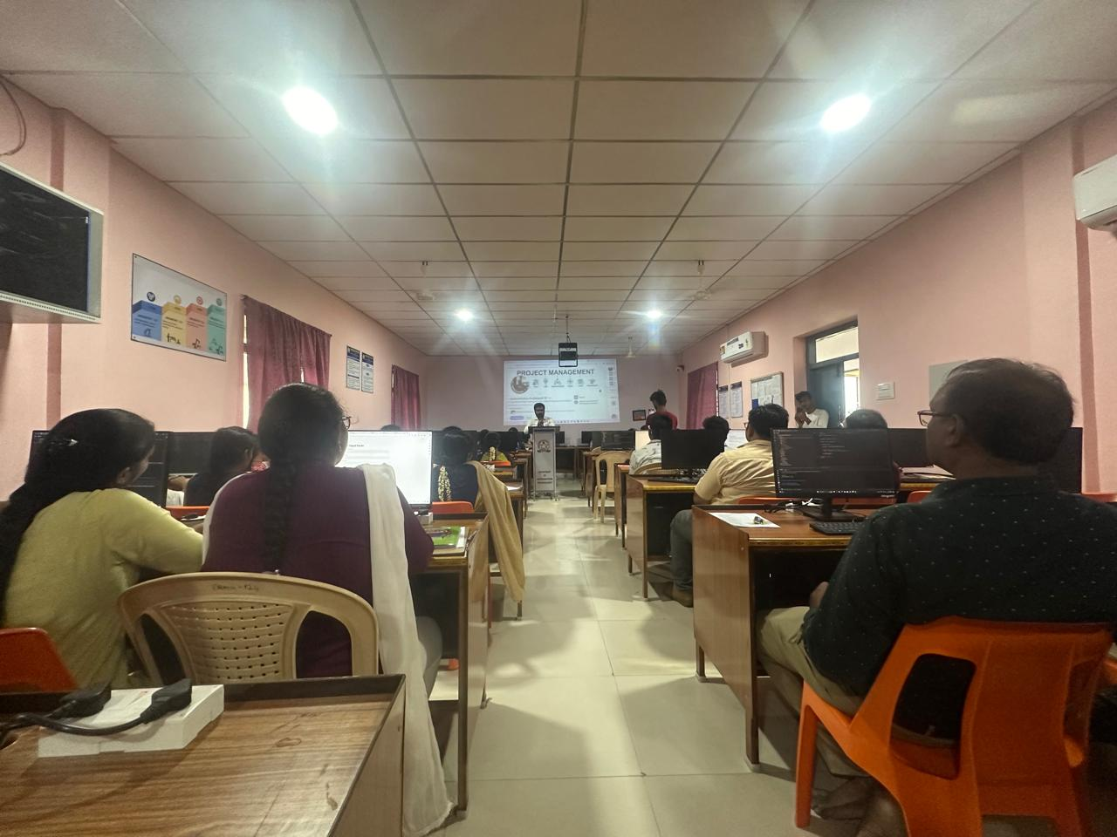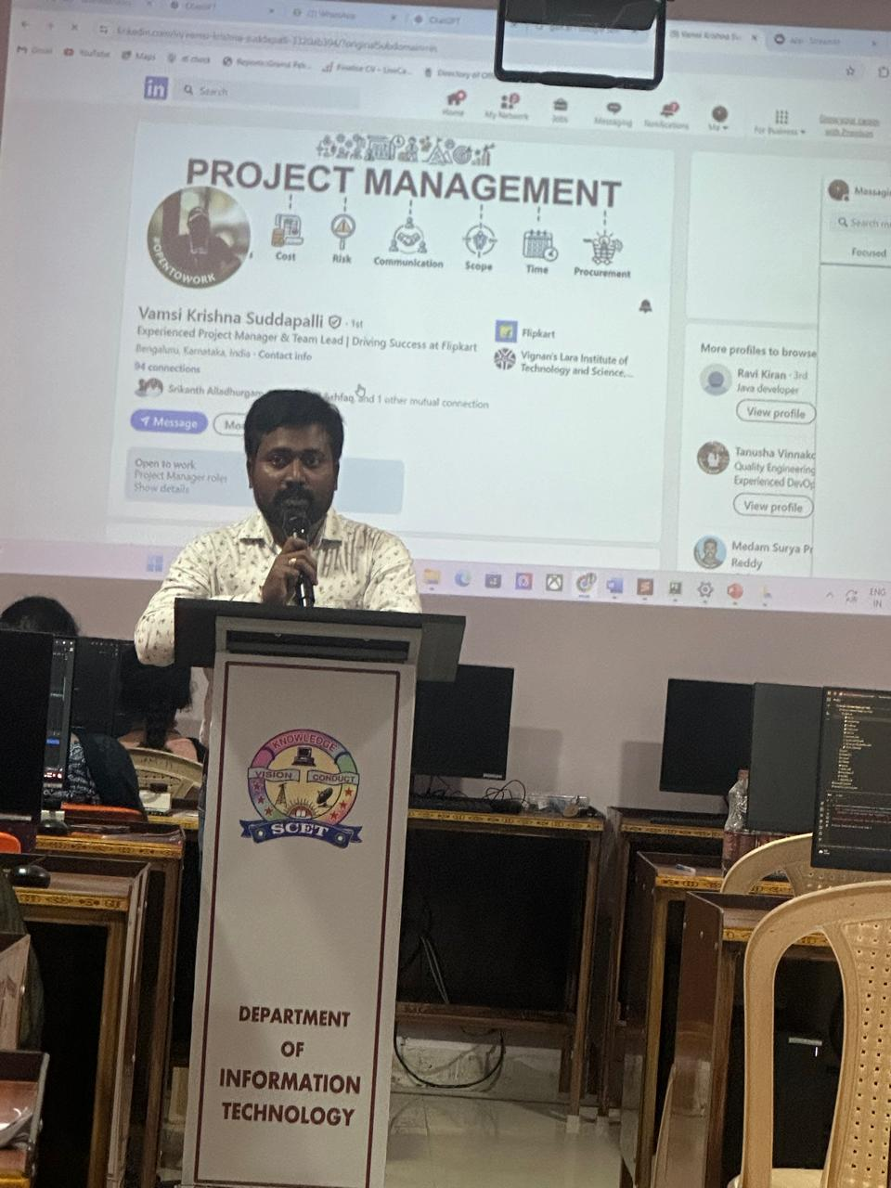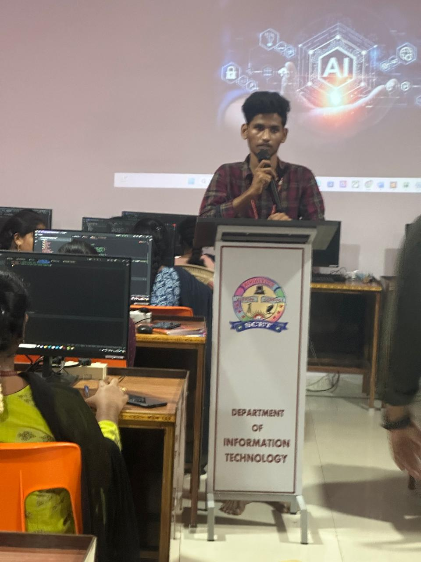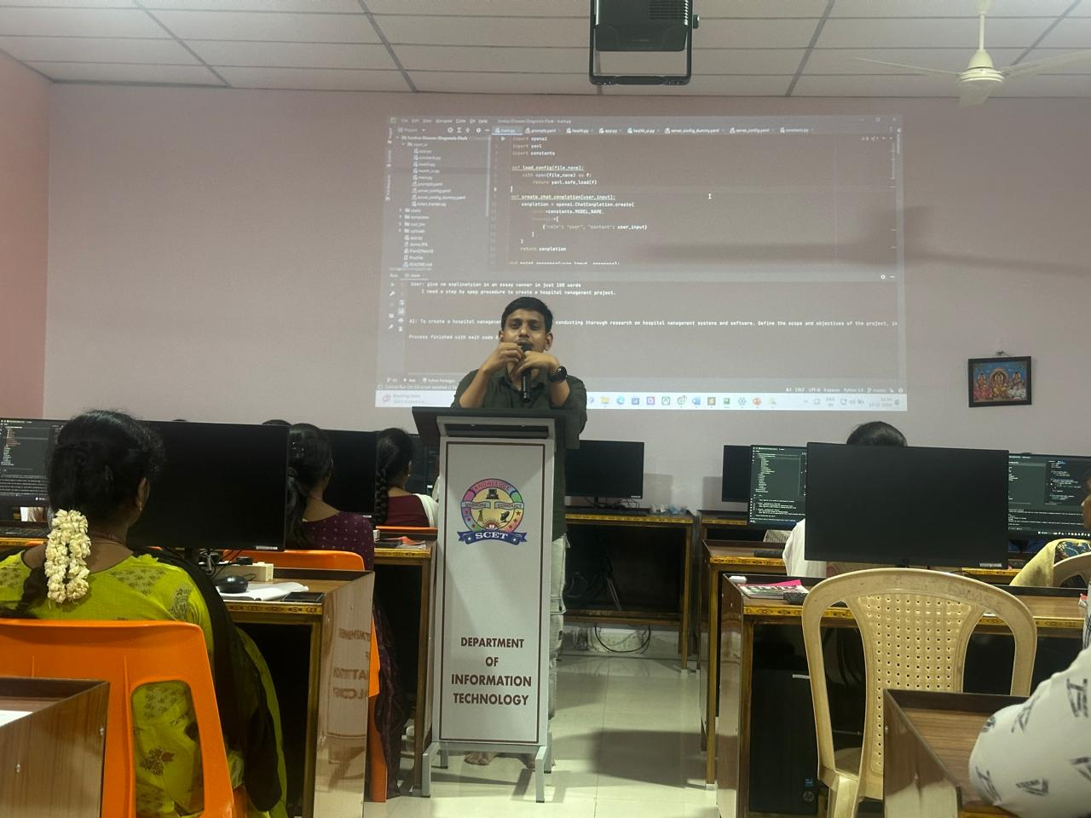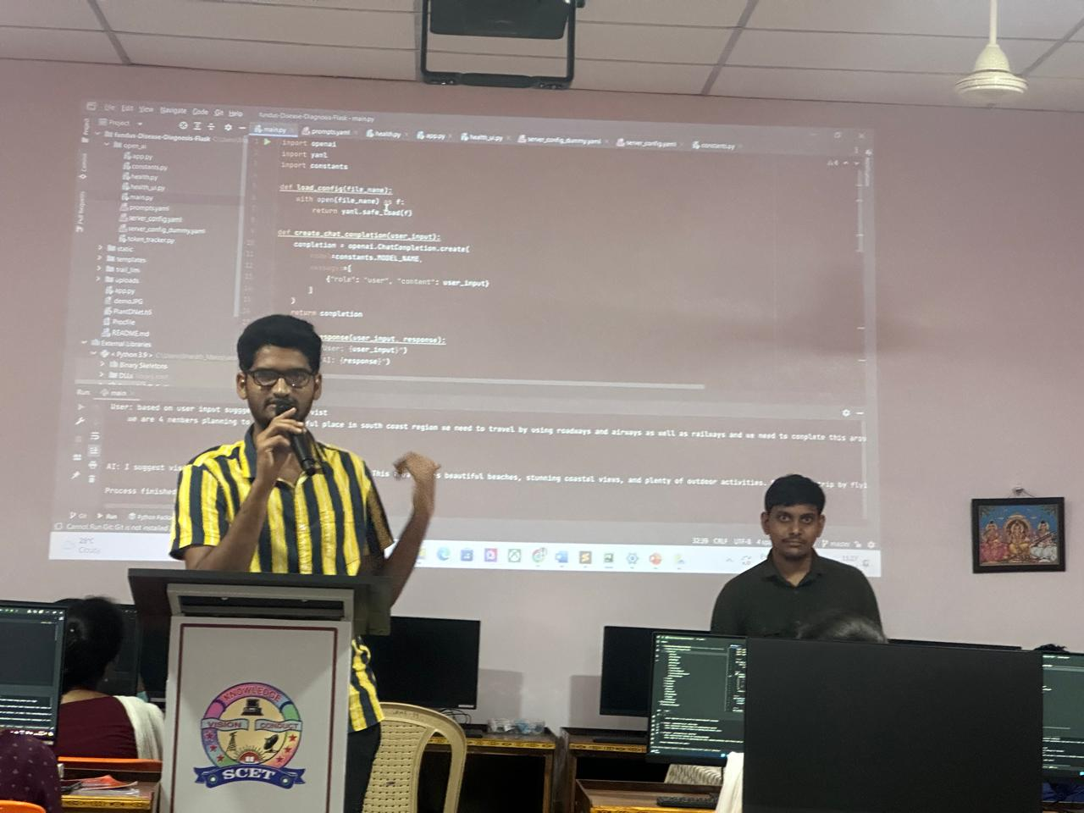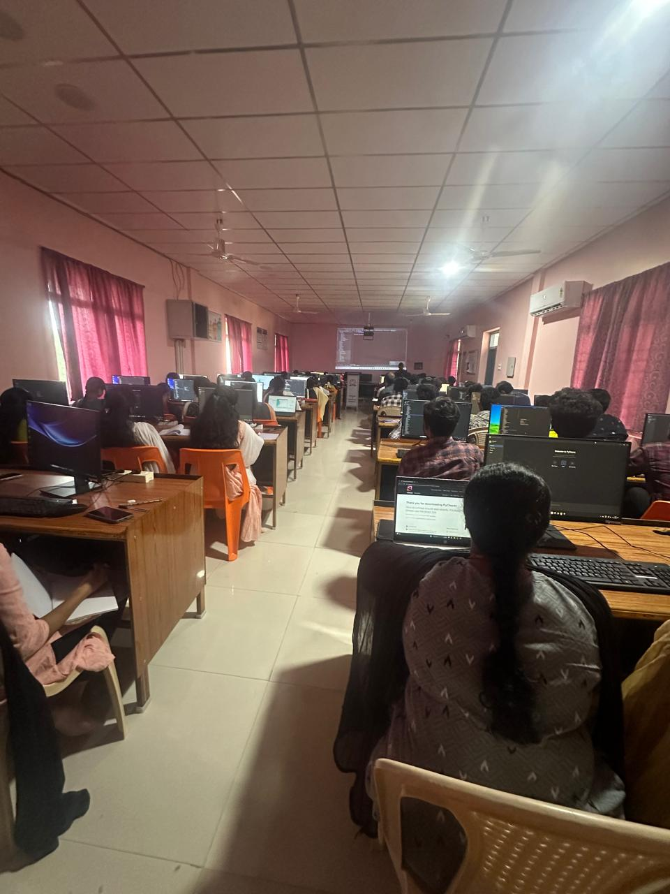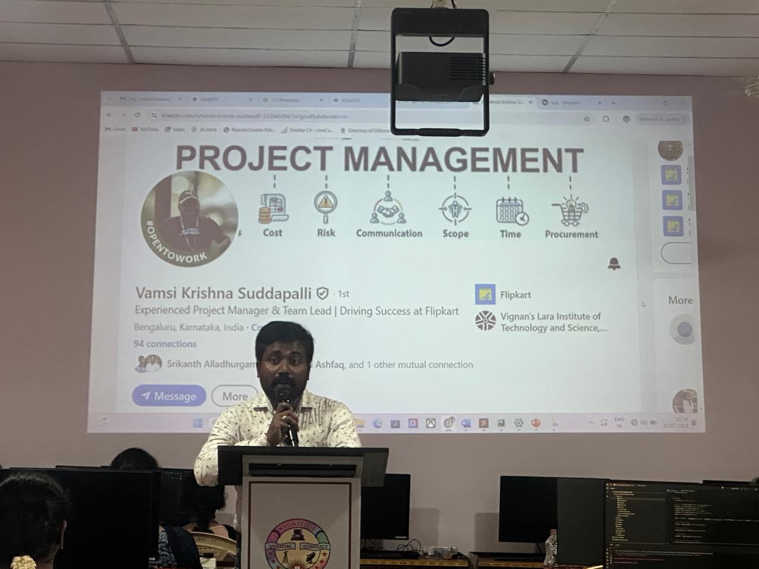

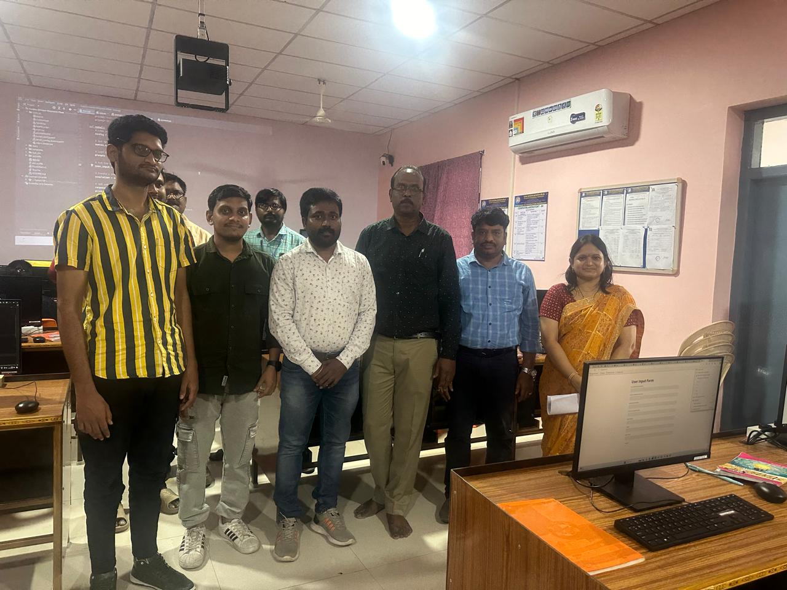

The webinar was closed with vote of thanks. 76 students were participated in this event. In this event 6 students were **IEEE** members out of 76 students were participated.

********